Key Findings
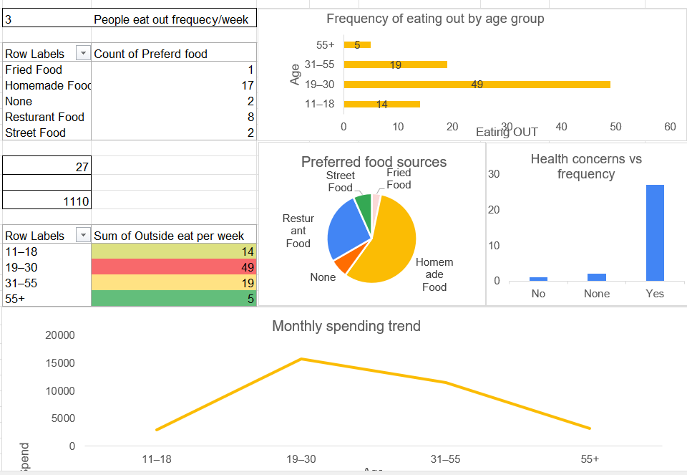
- The maximum Frequency of eating out by age group 19-30
- On an average spending per person on eating out is 1110 rupees /month
- The people average eat out 3 time per week
- Out of 30 responses 27 people are concern about health
- The age group 19-30 spends maximum on eating out
- The most of the people prefer homemade food
Suggestions –
- I would like to suggest try to have your daily meal on specific time
- Include protein-based food like fruits, dairy products and dry fruits in you diet
- Learn and get information about Eating Habit And Health awareness

